**Why this Data Model Design?**

The design follows **a star schema approach**, where a **central fact table is connected to multiple dimension tables**. This structure is **used for analytical processing in data warehouses and business intelligence (BI) applications** to simplifies queries and improve performance, where:

* **Fact tables**: contain measurable business events (e.g., Flights, Customer Feedback, Reservations)
* **Dimension tables**: provide descriptive attributes (e.g., Passengers, Airports, Aircraft).
* Foreign Keys (FKs): Connect facts to dimensions.

**What does the Data Represent?**

Each Data Mart represents different aspects of airline operations:

1. Flight Activity Mart: Tracks flight schedules, delays, and passenger movements.
2. Customer Feedback Mart: Stores Passenger reviews and ratings.
3. Reservation Mart: Manages ticket bookings, pricing, and statuses.

**Details About Each Data Mart Component:  
1) Flight Activity Data Mart:**

## 

**→ Fact Table: fact_flight_activity**

**Type**:

(Accumulating Snapshot fact table)

**Represents:**

Flight operations, including schedules, delays, and ticket information

**Surrogate Key**:

flight_id as a primary key of that fact table.

**Foreign Keys of:**   
(Date, Time, Passenger, Passenger Profile, Airport, Aircraft, Class Of Service, Fare Basis, Sales Channel)

**Degenerate Dimensions:**

(Confirmation_Number, Ticket_number, Segment_Sequence_number, Flight_number)

→ Important Facts:

| **Fact** | **Description** |
| --- | --- |
| base_fare_revenue | The core fare amount collected from ticket sales before any taxes or additional charges. |
| passenger_facility_charges | Fees imposed on passengers for airport maintenance and facility improvements. |
| airport_tax | Government-mandated taxes on air travel, typically charged per passenger. |
| government_tax | Additional taxation applied by the government on flight operations. |
| baggage_charges | Fees collected for checked or excess baggage beyond the airline’s free allowance |
| upgrade_fees | Charges applied when a passenger upgrades to a higher class of service (e.g, economy to business class). |
| transaction_fees | Service fees associated with booking or modifying reservations, often applied by airlines or third-party agencies. |
| segment_miles_flown | The total distance flown by a passenger for a given flight segment. |
| segment_miles_earned | The miles credited to a passenger’s frequent flyer account based on the flight distance. |
| flight_completed | A flag indicating whether the flight was completed or not |

→ Dimension Tables:

| **Dimension Name** | **Description** |
| --- | --- |
| dim_airport | This dimension represents different airports, including specific details about each airport, such as the city, country, or continent in which it is located. |
| dim_aircraft | This dimension represents different aircraft. Including specific details about each aircraft, such as the manufacturer, capacity, and the manufacturing year, etc |
| dim_class_of_service | This dimension represents different classes. In the aircraft as the (First class, Business Class, Premium Class, Economy Class) |
| dim_fareBasis | In this dimension we define the fare Rules. For example, the unrestricted FareBasis, Discount Fare, or Penalty for cancellations  Technically this table is used for pricing analysis and revenue optimization |
| dim_sales_channel | This dimension represents a different Sales Channel. How the tickets were booked. Whether an airline website, a Travel agency, or a phone booking. |
| dim_date | This dimension represents the date. In a format of year, day of month, Day of week, etc |
| dim_time | This dimension represents time. In a format of hours, minutes, and seconds |
| dim_passenger | This dimension represents the detailed information about the passenger. His name, email, phone, date of birth… etc |
| dim_passenger_profile | This dimension represents data about the passenger on each flight. Frequent Flyer Tier: whether he is basic or silver/Elite, and also the home airport from which he started the trip, and the mileage tier. |

**→ Aggregated Fact Table: agg_flight_trip**

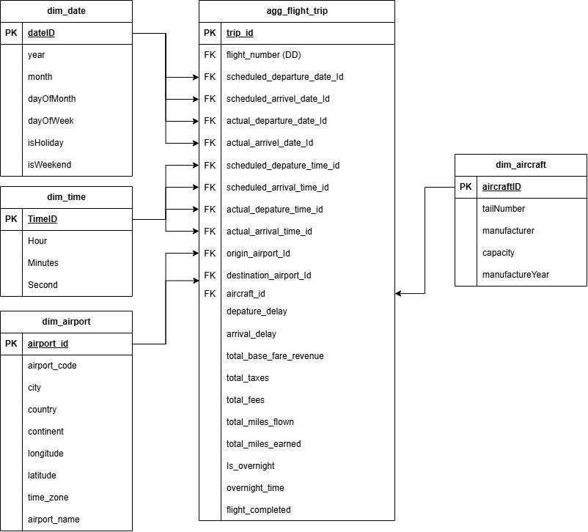

* **Purpose of agg_flight_trip Table**

This table provides an aggregated view of each flight trip, allowing for analysis of:

1. Flight delays and performance
2. Revenue Generation (Base Fare, Taxes, Fees)
3. Total miles flown and earned.
4. Operational insights such as overnight flights.

## **2) Reservation and company profit:**

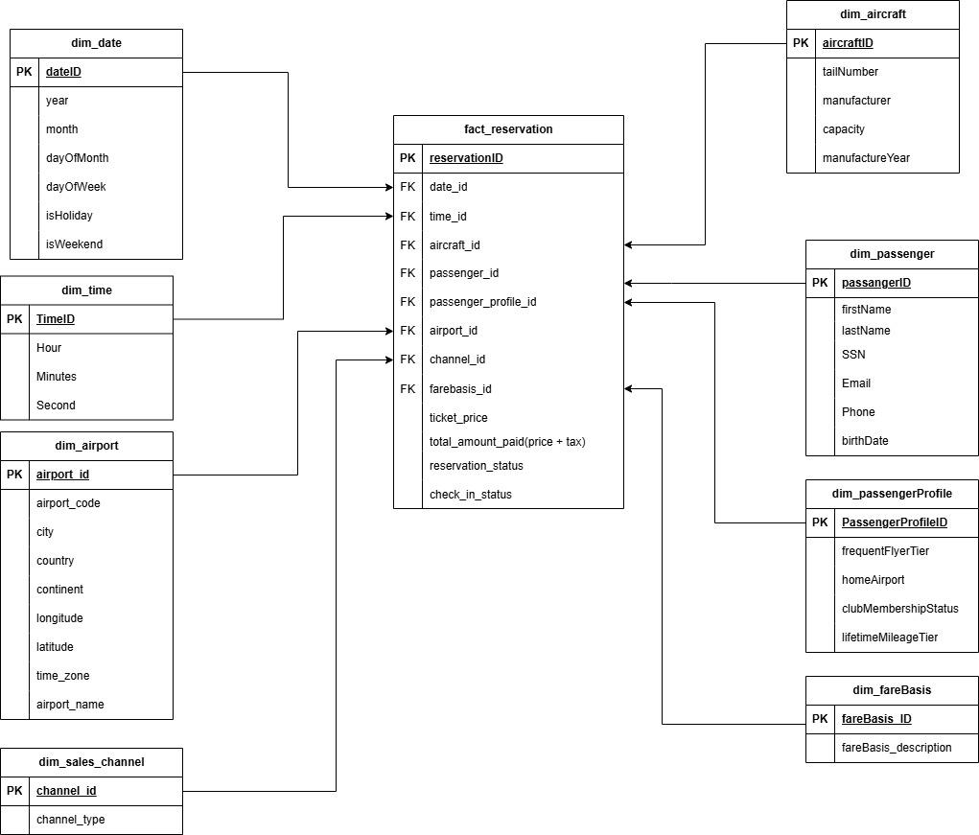

→ Fact Table: Reservation

* Type:

(Accumulating Snapshot fact table)

* Represents:

Reservation operations, including Ticket_Price, Total_Amount_Paid, Reservation_Status, and Check_in_status.

* Surrogate Key:

reservation_id as a primary key of that fact table.

* Foreign Keys of:

(Date, Time, Aircraft, Passenger, Passenger Profile, Airport, Fare Basis, Sales Channel)

| **Fact** | **Description** |
| --- | --- |
| Ticket_Price | It stores the ticket price by recording the base price of the ticket before taxes or additional fees are charged. |
| Total_Amount_Paid(Price + Tax) | It stores the total amount paid for the reservation.  by including the ticket price plus any applicable taxes or fees, representing the total cost to the passenger. |
| Reservation_Status | It indicates the current status of the reservation.  It can have values such as "confirmed," "pending," "canceled," etc., reflecting the state of the reservation. |
| Check_in_status | It indicates the check-in status of the reservation.  It can have values such as "checked in," "not checked in," reflecting whether the passenger has completed the check-in process. |

## **3) Customer inquiries, complaints and feedback for business enhancements:**

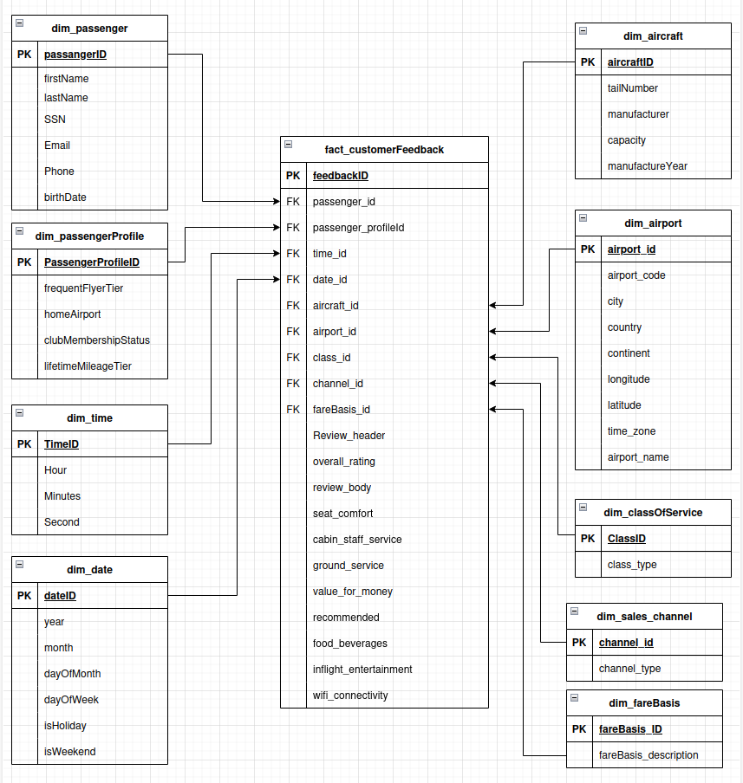

Here we have the third fact table in our project that discusses the airline’s customers feedback.

3) customer feedback Data Mart:

→ Fact Table: fact_customerFeedback

* Represents: Customer Inquiries, complaints, and feedback

| **Fact** | **Description** |
| --- | --- |
| Review_header | This fact represents an overview of the review that will be written by the passenger after the flight |
| overall_rating | This fact represents an overall rating of the flight from 1 to 10.  1: Terrible  10: Excellent |
| review_body | Represents the actual specifications of the feedback that the customer provided in detail.  1:vague  5: informative |
| seat_comfort | This fact represents the rating of the passenger seat comfort from 1 to 5.  1:padded poorly  5:cozy |
| cabin_staff_service | This fact represents the rating of the cabin staff and services on the plan from 1 to 5.  1:unattentive  5: Accommodating |
| ground_service | This fact represents the rating of the ground staff and services on the airport from 1 to 5.  1: Unprofessional  5: Welcoming |
| value_for_money | This fact will let the passenger rate the value he had over the value he paid after the flight from 1 to 5.  1: was really poor  5: was really rewarding |
| recommended | This fact represents the customer recommendation of the airline ‘0’ for not recommended and ‘1’ for recommended. |
| food_beverages | This fact will let the passenger rate food beverages from 1 to 5.  1: The food was rotten/spoiled.  5: food was fresh and delicious |
| inflight_entertainment | This fact will let the passenger rate the inflight entertainment whether he got entertained or not after the flight from 1 to 5.  1: Boring  5: Enjoyable |
| wifi_connectivity | This fact will let the passenger rate the wifi connectivity after the flight from 1 to 5.  1: The internet was unstable and very slow.  5: The internet was stable and the connection was smooth. |